**How to resolve Hierarchical Parser/Builder Error:** Cannot create an Unstructured Data transformation.

This error happens when the server where the secure agent is installed cannot process Hierarchy data transformation.

I can suggest two things you can check to troubleshoot this error.

1. Make sure the UDTforHierarchy package is installed in the agent. To check this, go to Runtime Environments under the Configure tab and see Agent Package Details. If this is not enabled, contact Informatica Support.

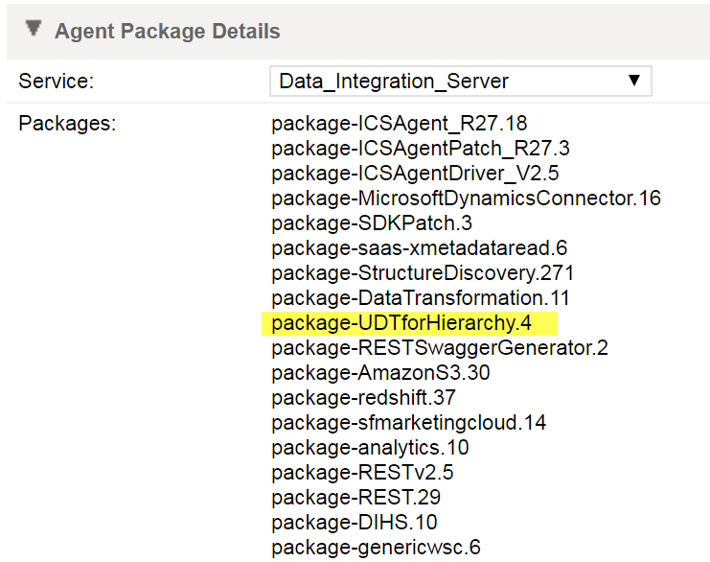

1. Increasing the Tomcat JRE INFA_MEMORY to -Xms32m -Xmx1024m -XX:MaxPermSize=128m sometimes help. This can be done from Edit Secure Agent.

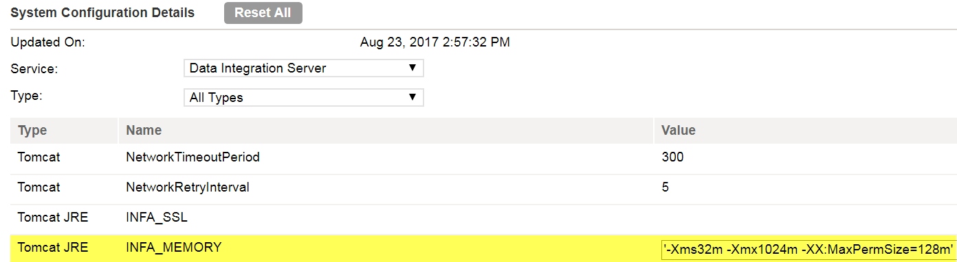

1. Make sure that you have the Linux version supported by the Secure Agent. You can get this information from Informatica Support.

In Redhad, you can check the linux version as below.

Cat /proc/version

Cat /etc/*release*

**How to use Hierachical Parser to Transform JSON files**

1. Firstly, we need to create a schema for the JSON file. Go to the Hierarchical Schema option under the Configure tab.

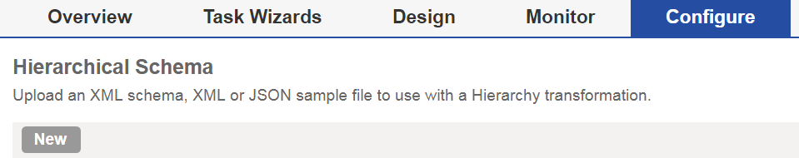

1. Upload Schema or sample file for the JSON file you want to transform. This can be uploaded from your computer. Click OK to create the schema which will be used in the Mapping job.

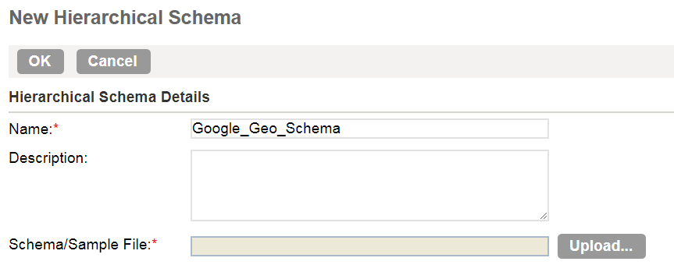

1. Go to the Mapping canvas. In this example, we will use Source, Hierarchy Parser and Target as below

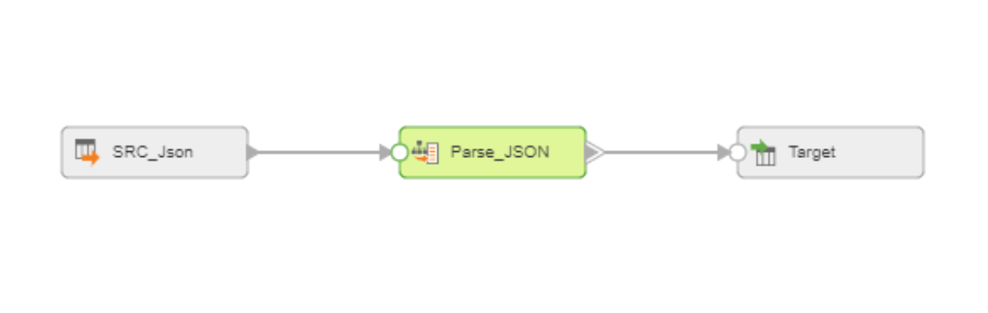

1. You need to prepare a file that contains the path to the actual JSON file in the server and use it as the Source Object.

For example, the path to the actual JSON file in the Linux server is "/tmp/Informatica_Test/demo_google_geo.json", the path file looks like below.



1. Configure the Source. Choose the path file as the Object.

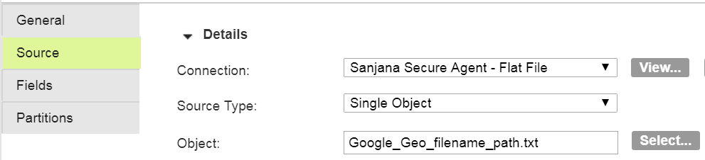

1. In Hierarchy Parser, add the previously configured schema in Input Settings.

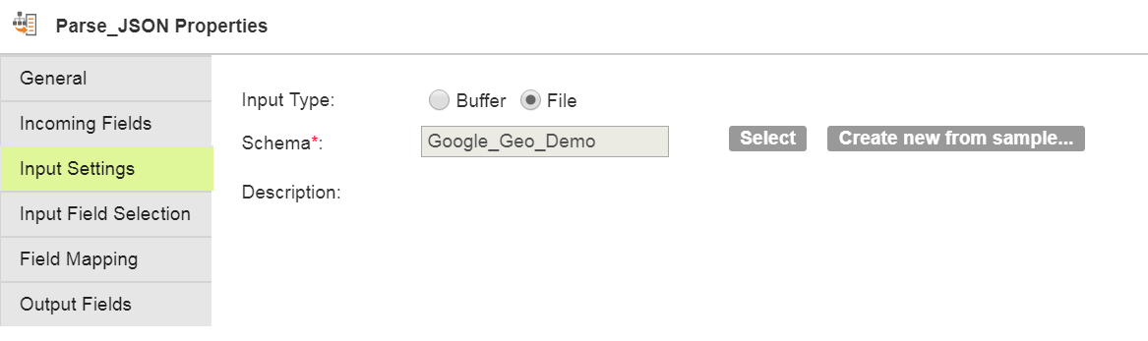

1. Go to Input Field Selection, map ‘path’ from the incoming fields into the field name, ‘Input’ as below.

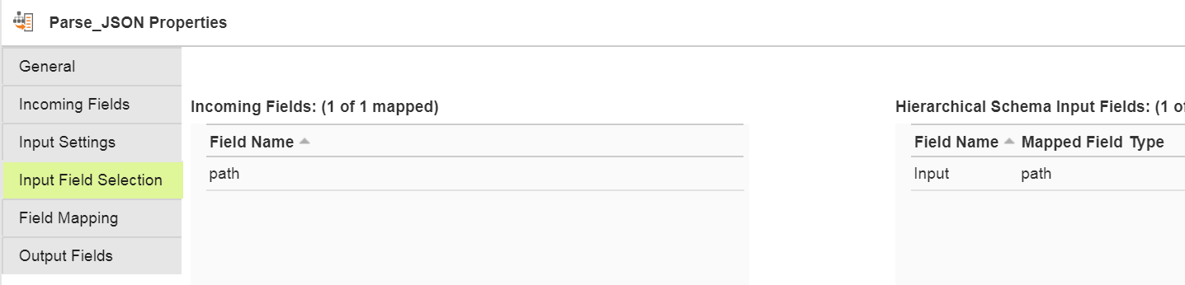

1. In Field Mapping, choose the elements that you want to map.

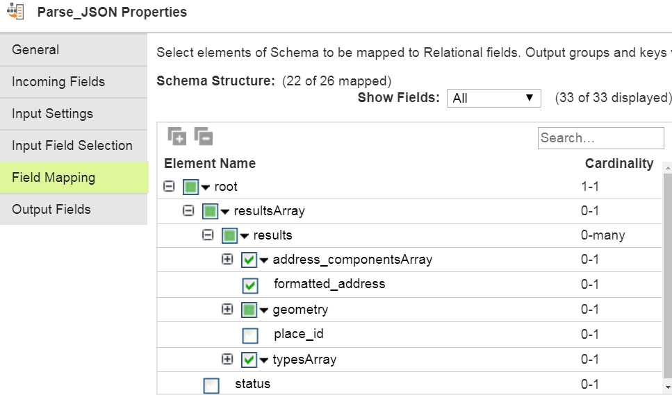

1. You can choose either ‘Relational’ or ‘Denormalized’ as an output format. When choosing Relational, Informatica automatically creates the data model and keys. With the denormalised format, the denormalised table gets created automatically. In this example, we will use the denormalised format as output.

Relational Option

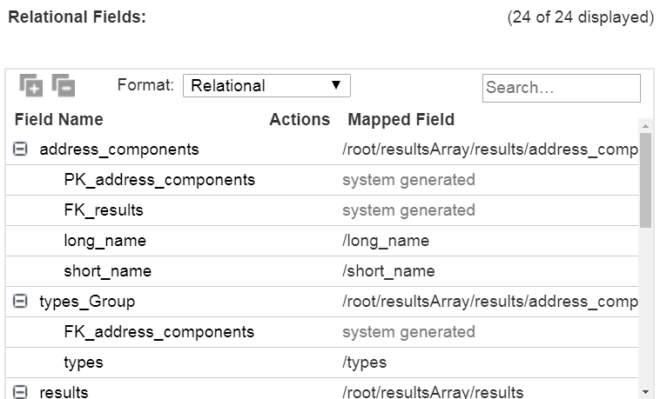

Denormalised Option

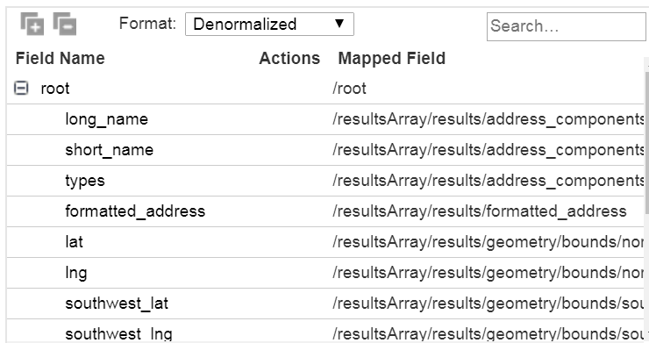

1. Select the output group. In the denormalised format, we will only have one group to select

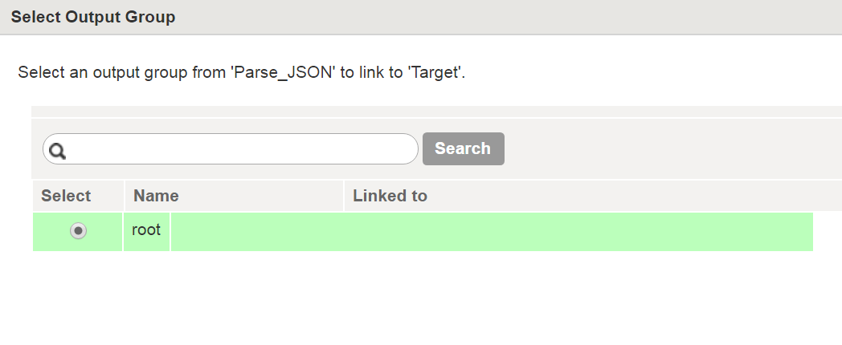

In the relational format, you can select Output Group.

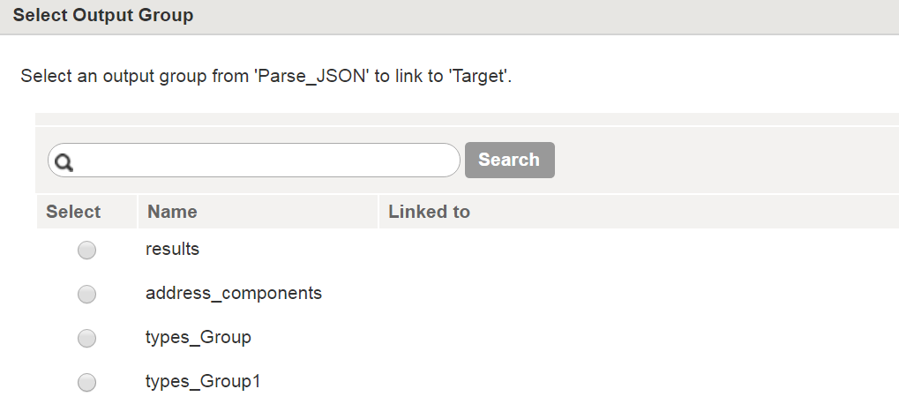

1. Configure Target and Run.